ASSIGNMENT - 1

NORMALIZATION
1.Observe the structures of a given EMPLOYEE table as below and suggest if this table can be
further normalized

EMPNO, ENAME, SAL, DEPTNO, DNAME, LOC

Explain what normal form this table is and how you can make this into next normal form.
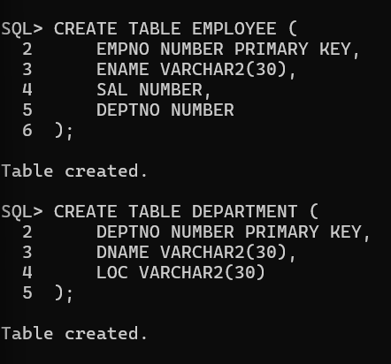

2.Observe the structures of a given STUDENT table as below and suggest if this table can be
further Normalized

ROLLNO, NAME, AGE, EXAM, MARKS, GRADE

Explain what normal form this table is and how you can make this into next normal form.
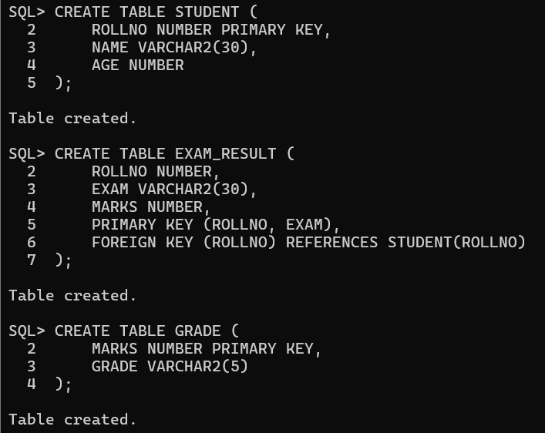

3.Observe the structure of a given EMPLOYEE table and suggest what kind of problem this table has
and how to solve the problem.

EMPNO, PROJECT_NO, NO_OF_DAYS, CUSTOMERNAME

In the above table EMPNO and PROJECT_NO both are together a composite primary key.
